Task 4: Order Management using Joins
Aim: To design and develop an order management system using SQL joins and subqueries to display customer order history, identify the highest value order, and determine the most active customer.
Algorithm:
- Start the program
- Connect to the database
- Retrieve data from Customers, Orders, and Products tables
- Apply JOIN to combine data from all tables
- Calculate total order value (price × quantity)
- Sort data using ORDER BY
- Find highest value order using subquery (MAX)
- Find most active customer using GROUP BY and COUNT
- Display results on the web page
- Stop the program
Program:
Orders.php:
<?php
include 'db.php';
/* ===============================
1. CUSTOMER ORDER HISTORY (JOIN)
================================= */
$sql = "SELECT c.name, p.product_name, p.price, o.quantity, o.order_date,
(p.price * o.quantity) AS total
FROM orders o
JOIN customers c ON o.customer_id = c.customer_id
JOIN products p ON o.product_id = p.product_id
ORDER BY o.order_date DESC";
$result = $conn->query($sql);
/* ===============================
2. HIGHEST VALUE ORDER (SUBQUERY)
================================= */
$highest_sql = "SELECT MAX(p.price * o.quantity) AS max_order
FROM orders o
JOIN products p ON o.product_id = p.product_id";
$highest_result = $conn->query($highest_sql);
$highest_row = $highest_result->fetch_assoc();
/* ===============================
3. MOST ACTIVE CUSTOMER
================================= */
$active_sql = "SELECT c.name, COUNT(*) AS total_orders
FROM orders o
JOIN customers c ON o.customer_id = c.customer_id
GROUP BY c.customer_id
ORDER BY total_orders DESC
LIMIT 1";
$active_result = $conn->query($active_sql);
$active_row = $active_result->fetch_assoc();
?>
<!DOCTYPE html>
<html>
<head>
<title>Order Management System</title>
<style>
body { font-family: Arial; background: #f2f2f2; }
.container {
width: 85%;
margin: auto;
background: white;
padding: 20px;
}
table {
width: 100%;
border-collapse: collapse;
margin-top: 20px;
}
th, td {
padding: 10px;
border: 1px solid black;
text-align: center;
}
h2 {
color: blue;
}
.highlight {
background: #e6f7ff;
padding: 10px;
margin-top: 15px;
}
</style>
</head>
<body>
<div class="container">

<h2>Customer Order History</h2>
<table>
<tr>
<th>Customer</th>
<th>Product</th>
<th>Price</th>
<th>Quantity</th>
<th>Total</th>
<th>Date</th>
</tr>
<?php while($row = $result->fetch_assoc()) { ?>
<tr>
<td><?php echo $row['name']; ?></td>
<td><?php echo $row['product_name']; ?></td>
<td><?php echo $row['price']; ?></td>
<td><?php echo $row['quantity']; ?></td>
<td><?php echo $row['total']; ?></td>
<td><?php echo $row['order_date']; ?></td>
</tr>
<?php } ?>
</table>
<div class="highlight">
<h2>Highest Value Order</h2>
<p>₹ <?php echo $highest_row['max_order']; ?></p>
</div>
<div class="highlight">
<h2>Most Active Customer</h2>
<p>
<?php echo $active_row['name']; ?>
(<?php echo $active_row['total_orders']; ?> orders)
</p>
</div>
</div>
</body>
</html>

Database:
CREATE DATABASE order_db;
USE order_db;
CREATE TABLE customers (
customer_id INT AUTO_INCREMENT PRIMARY KEY,
name VARCHAR(100)
);
CREATE TABLE products (
product_id INT AUTO_INCREMENT PRIMARY KEY,
product_name VARCHAR(100),
price INT
);
CREATE TABLE orders (
order_id INT AUTO_INCREMENT PRIMARY KEY,
customer_id INT,
product_id INT,
quantity INT,
order_date DATE
);
-- Sample Data
INSERT INTO customers (name) VALUES
('Alice'), ('Bob'), ('Charlie');
INSERT INTO products (product_name, price) VALUES
('Laptop', 50000),
('Phone', 20000),
('Headphones', 2000);
INSERT INTO orders (customer_id, product_id, quantity, order_date) VALUES
(1,1,1,'2024-01-01'),
(1,2,2,'2024-01-05'),
(2,3,5,'2024-01-03'),
(3,1,1,'2024-01-04'),
(2,2,1,'2024-01-06');

Output:
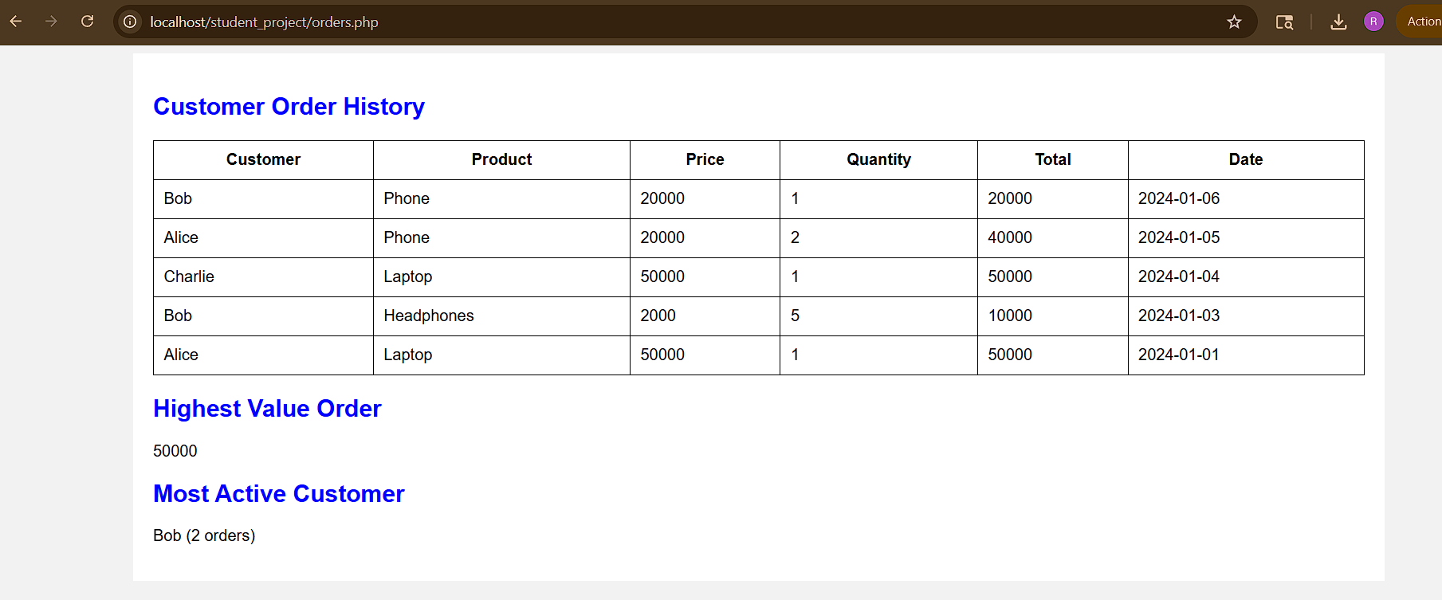

Result: Thus, the order management using joins in sql has been successfully completed and output generated successfully.

